For this assignment, we will be using some datasets and functions in the TSA package in R. For instructions on how to install and load the package, please see the Week 2 module on Canvas.

(4 marks) The gold dataset in the TSA package gives the daily price of gold (in $ per troy ounce) for the 252 trading days of 2005.

(a) Suppose we were to try fitting an AR(1) model to this dataset. Fit this model using the arima() function in R. Give the estimates of φ and µ. (Note: As we saw in Video 32, the coefficient named “intercept” in the arima( ) output is actually referring to the mean µ, NOT the intercept θ0.)

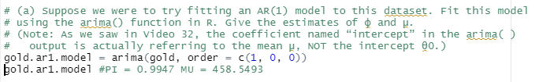

(b) Create a plot of the (standardized) residuals vs. time for this model. Interpret what you see in the plot.



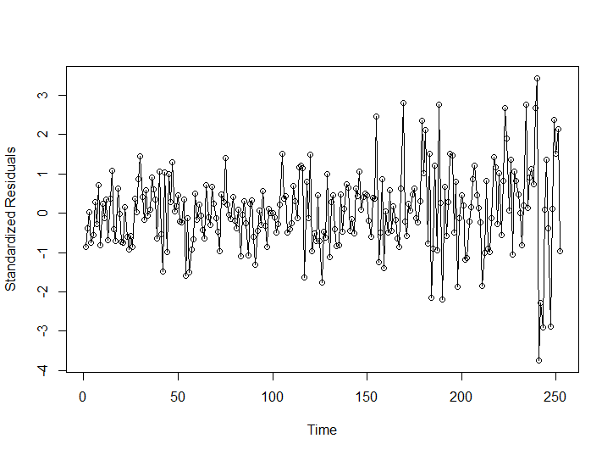

* The standardized residuals get bigger as time goes and go too up and down.

(c) Create a Q-Q plot of the (standardized) residuals for this model. Interpret what you see in the plot.



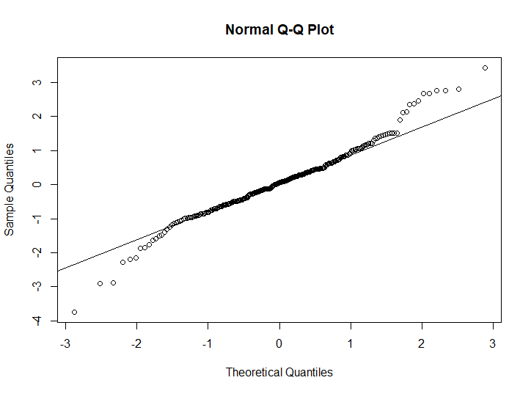

-> It quite looks like normal, but there are some points that are far from the line.

(d) Create the sample ACF plot of the (standardized) residuals for this model. Interpret what you see in the plot.



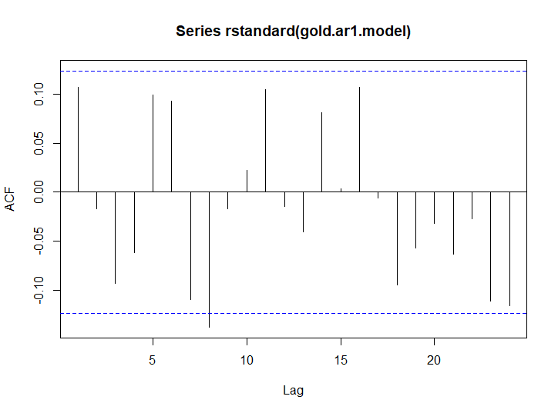

* It looks like that there might be some negative correlation in residuals.